Line of Business: Typelists  
Exercise 1: Investigation  
  
To assist with your work in this lab, the six LOB model typelists are:

|  |  |
| --- | --- |
| **1. LossType**  **2. LOBCode**  **3. PolicyType** | **4. CoverageType**  **5. CoverageSubtype**  **6. ExposureType** |

**NOTE:** When performing the configurations in this lab, if you run into difficulties, use the “Revert to Base” or “Local History” feature of Studio. That way you can revert to a previous version of a typelist extension. “Revert to Base” restores to the installed version, and “Local History” allows you to revert to a previous revision.

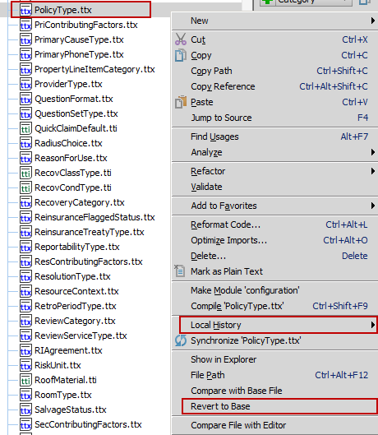

Answer the following questions about the line of business model in the base application.

1. Which loss type has the largest number of LOB codes?

2. Which policy type belongs to more than one LOB code? What codes does it belong to?

3. Which policy type is retired?

4. Are any coverages shared by both the General Liability and Professional Liability policies?

5. Compare these two coverages: "Farmowners" and "Earthquake". Do they both map to the same number of exposure types? Do they map to the same exposure type?

6. View the General Liability coverage. It maps to nine coverage subtypes, but it maps to only four exposure types. Why do you think this coverage maps to a multiple exposure type in more than one way?

**Exercise 2: Configuration**

Configure ClaimCenter to meet the following customer requirement from Acme Insurance.

**Requirement 1: Earthquake Coverage Does Not Map to Content Exposure Type**

In the base application, the (Homeowner's) **Earthquake Coverage** (code HODW_Earthquake_HOE) maps to three exposure types: **Dwelling, Other Structure, and Content**. However, the ACME claims process for this coverage does not require the capturing of information for Content Damage, and they want their Earthquake coverage to map only to the Dwelling and Other Structure exposure types. In other words, they will not offer Content as part of their Earthquake coverage.

7. Modify the Earthquake coverage so that it no longer allows the option to create a "Content" exposure type. **Hint:** Do **not** **remove** **any typecodes** from parents.

*Remember that all data model changes, including changes to the LOB, require a server restart.*

**Test Cases: Requirement 1**

When you have completed your configuration, run the following test cases:

8. Navigate to a claim for a Homeowner's policy (such as claim 426-24-366170 (for Ken Darion)). (You can log in as William Dufraine – wdufraine/gw.) Verify that you can create an exposure tied to Earthquake coverage, but none of the options lead to a screen labeled "New Exposure - *Content*".

**Base Application:**

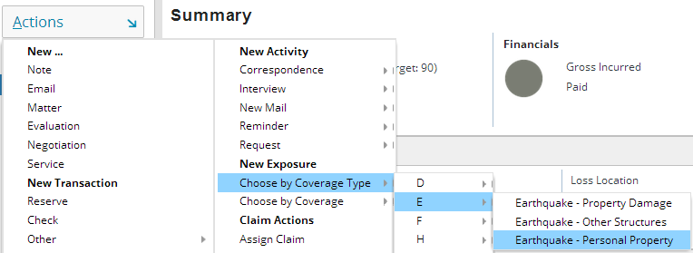



**Requirement 1 Implemented:**

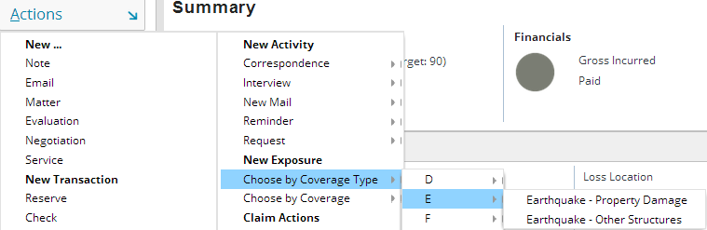

**Requirement 2: New Erosion Coverage**

Acme Insurance offers Erosion coverage with its policies. It covers losses to homes due to erosion. However, there is no such coverage in ClaimCenter's line of business model in the base application.

9. Modify the line of business model so that an adjuster working on a claim tied to a homeowner's policy can create an exposure associated to Erosion coverage. For the time being, you can map the coverage to the Dwelling exposure type. (The internal code for the Erosion coverage should be "ERO".)

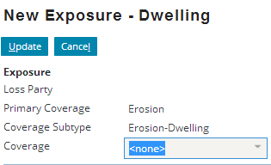

**Test Cases: Requirement 2**

When you have completed your configuration, restart ClaimCenter, then run the following test case:

10. Navigate to a claim for a Homeowner's policy (such as 426-24-300170 (John Albertson)). Create an erosion exposure.

**Requirement 2A: Completing the Erosion Coverage**

At this point, you should be able to create exposures using the erosion coverage and reserve lines for these exposures. But, Acme Insurance users need certain information connected to all exposures and coverage types.

Each new exposure must have a stated Loss Party. For the erosion coverage, this should be "Insured's loss".

Old look (see test cases for New look):



When a reserve line is created using the Erosion coverage, if the cost type is Claim Cost, then the following options should appear for cost categories: Labor, Mileage reimbursement, Other, Unspecified Cost Category.

Old look (see test cases for New look):

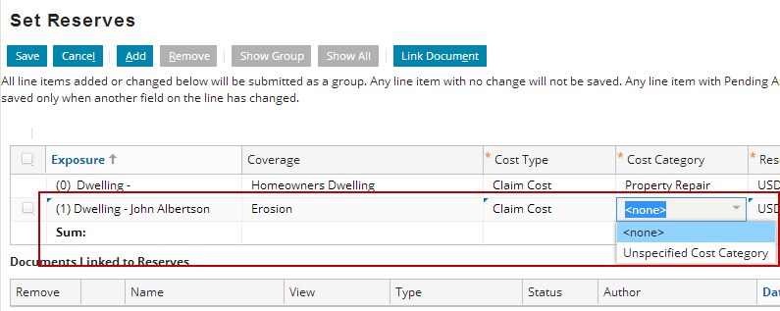

11. Modify ClaimCenter so that:

* Exposures mapped to the Erosion coverage have a loss party of "Insured's loss".
* For reserve lines mapped to erosion exposures, a reserve line with cost type "Claim Cost" can have a cost category of "Labor", "Mileage reimbursement", "Other", "Unspecified Cost Category".

12. The ClaimCenter implementation team has provided additional notes:

* This requirement should be implemented solely through typelist modification. Do not write any GOSU rules or functions to enforce this.
* Use the data dictionary to locate the data model fields for Exposure's Loss Party and the Reserve's Cost Category to determine what are the current possible values

**Test Cases: Requirement 2A**

When you have completed your configuration, run the following test cases:

13. Navigate to a claim for a Homeowner's policy (such as 426-24-366170). Create an erosion exposure. Verify that the loss party field is set to "Insured's loss".

New look:

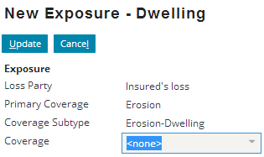

14. Create a reserve line for the exposure. Verify that there are now four options for cost category when cost type is "Claim Cost".

New look:

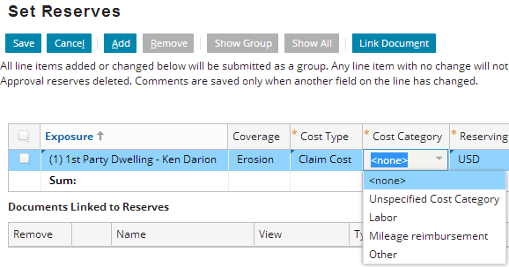

Bonus Task

Complete these requirements only if your instructor tells you to do so.

**Requirement 3: Removing the "Extra Expenses" Coverage**

Base ClaimCenter comes with an “Extra Expenses” coverage that is available on two policy types – Commercial Property and Commercial Package. Acme Insurance does not sell "Extra Expenses" coverage on their Commercial Property policies. During initial user acceptance, the implementation team does not want test users to be able to create "Extra Expenses" exposures, as they feel it will be a source of confusion for them. However, the acceptance testing will focus on new claim creation, so they are not concerned about any policies in the test data with Extra Expenses coverage.

15. Modify the line of business model so that Acme Insurance users cannot create exposures pertaining to the Extra Expenses coverage on Commercial Property policies, but they can still create them on Commercial Package policies.

OLD:

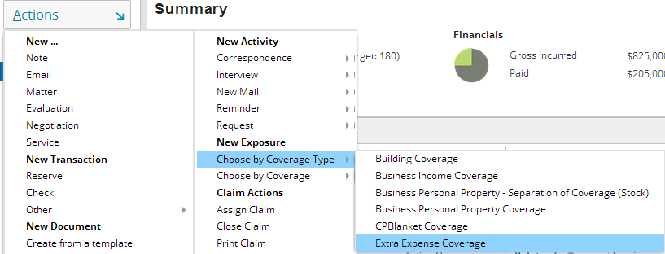

16. The ClaimCenter implementation team has provided additional notes:

* Do not retire or delete the Extra Expenses coverage type (or coverage subtype), because it is still required for Commercial Package policies.
* Do not retire or delete the Loss of Use Exposure Type as this is used by other coverages which are not being eliminated, such as Business Lost Income and Trees Removal.
* HINT: Examine the Coverage Types and Subtypes involved with Extra Expenses and configure them as needed.

**Test Cases: Requirement 3**

When you have completed your configuration, run the following test cases:

17. Navigate to a claim 426-24-366071, which is a Commercial Property claim related to a policy with Extra Expenses coverage. Verify that you can view the Extra Expenses coverage on the Policy>Locations screen, for risk #1.

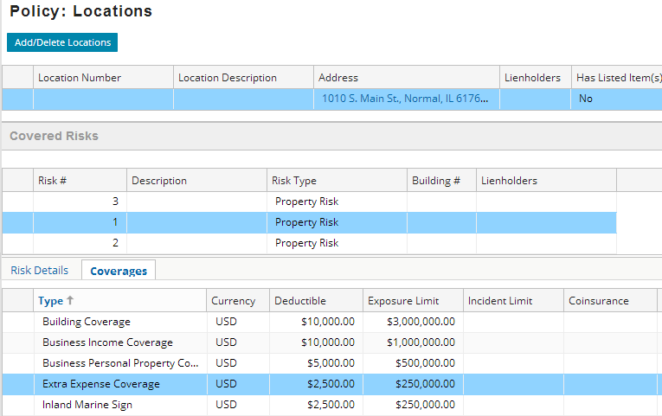

18. On the same claim, verify that you cannot create an “Extra Expenses” exposure (through the “Choose by Coverage Type” menu) which uses the LOB definition to determine available exposures.

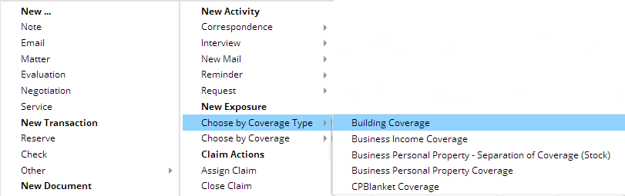

19. (OPTIONAL) To test further, create an unverified Commerical Package policy and file a claim against it. Make up details as needed. Confirm that you **can** create an “Extra Expenses” exposure:  
  
